PRODUCTS
Capture Solutions | Easy Stream R & B → WX-E Series
 | Indoor R & B → WX-AL Series
 | Portable R & B → WX-AX Series
 | Premium R & B → WX-Z Series
 | Practical Training R & B → WX-MCP Series
Interactive Touch Displays | LG 3576 插拔摄像头MP Pro Series
 | V100带摄像头EU Series
 | Ultral黑板
 | Ultral Il白板
Digital Signage | Digital Signage商业广告牌
LED Solutions | LED
Supporting Solutions | Smart Podium
 | Smart Mobile Screen
 | Mobile Stand
 | OPS
 | Conference Kits
 | Stylus
 | Pluggable Camera
 | Digital Class Signage电子班牌
Software Kits | WNEX Share投屏
 | WNEX Meeting 远程互动
 | WNEX Group 小组讨论
 | WNEX TabletLinks Pad教学
 | WNEX DMS

一屏列大的特点
二屏列特点
- 四、五、六、七屏产品细节特点-宣传亮点
八屏是产品视频预览窗口
九屏产品规格参数

Capture Solutions
Easy Stream R & B
·8-core CPU ·8G + 512G
·stable embedded design ·4K decoding & display
·live streaming, interaction, recording and shooting, All-in-one
·dual lenses: panoramic & close-up ·built-in AI algorithm

Highly Efficient, Effortless Deployment
Low power consumption, high performance. POE one-cable connection for quick deployment.
One EASY STREAM can simultaneously distribute to up to 50 electronic blackboards.
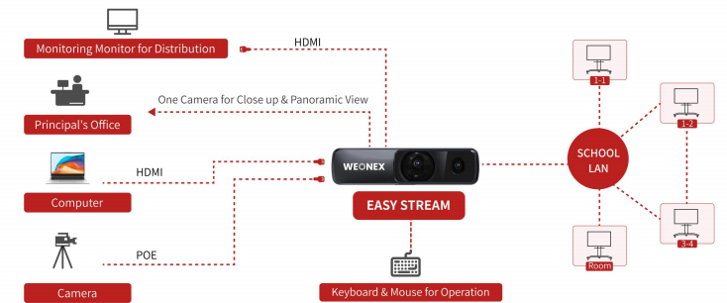

AI Analysis & Speech Transcription
Real-time statistics and display of classroom activities and behaviors; automatic voice analysis and keyword extraction for lectures.

Simultaneous Streaming
Supports up to 4 concurrent streams, including YouTube and on-campus network broadcasts, facilitating remote event participation.

Real-time Classroom Observation
Observation by classroom allows for quick location of target classrooms. Observation by course, which focuses on professional teaching, supports classroom observation based on course categories, specialized courses, and supervisor groups in accordance with the curriculum schedule, enhancing the pertinence of work.
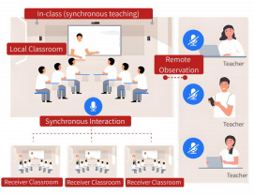
Live Streaming Function
Large displays across campus (principal' s office, staff room, classrooms, etc.) support direct live streaming, letting students watch assemblies/events in class-ideal for pandemic protocols or special scenarios.

Dual Cameras
9.29MP and 4.93MP dual cameras enable simultaneous multi-angle transmission, supporting versatile scenes and varied broadcast perspectives.

Multi-Input & Switching
Up to 4 input channels (HDMI, LINE) for easy recording,distribution, screen switching, and video synthesis - handles multiple sources at once.

（视频预览）

SPECIFICATION

Indoor R & B
·4K decoding and display ·built-in AI analysis
·8G + 1T storage ·8-core CPU
·live streaming, interaction, and interaction, All-in-one
·wall-mount design ·stable embedded design
·17.3-inch multi-point touch screen
·POE supplies power, control and signal transmission
·multi-channel video preview

User-Friendly Touch UI
With visualized UI design, the HD touch panel enables effortless manual operation. Users can start recording, push streaming and switch live views with one tap to generate complete and high-quality recorded course videos efficiently.

Powerful Integrated Capabilities
Featuring a 17.3-inch HD touch LCD screen, the device supports full-touch operation and visual control.
It delivers powerful integrated capabilities for recording and live broadcasting. It supports real-time preview of multi-channel video sources including cameras and teacher PCs, along with scene switching, logo & subtitle overlay, transition effects, volume adjustment, PTZ focus control and multi-view layout display.

Smart AI Analysis
Built-in AI algorithm also supports fully offline smart analysis.
The system enables real-time headcount and detects common student behaviors. It clearly visualizes classroom data. It also provides real-time audio analysis, automatic transcription, key content extraction and keyword statistics to support smart teaching.

Easy Deployment
A space-saving wall-mounted design fits perfectly into ordinary classrooms without occupying extra space. All audio and video devices run on a single network cable, requiring no special renovation or construction work.

Remote Collaboration and Compatibility
Enables multi-site real-time interaction with high-definition visuals and minimal latency. Multi-protocol support ensures seamless integration with third-party meeting software.

Resource Management Platform
Seamlessly integrated with mainstream education systems, our solution supports cross-regional interactive learning.
All class recordings are saved in the cloud for flexible on-demand playback and self-paced learning anytime, anywhere.

（视频预览）
SPECIFICATION

Portable R & B
·one package to carry ·1TB Storage
·5mins quick setup ·4K decoding & display
·wireless connection ·8-core CPU
·built-in battery, 6hrs continuously working
·recording, live streaming and interactive, All in One
·built-in AI analysis ·4K AI tracking
Quick Wireless Connection
The portable R & B host and wireless PTZ camera both support wireless network transmission. Simply position the devices for your shot, and they connect automatically upon power-on. No additional assistance required.

One Package to Carry
Embedded design with built-in battery. All-in-one for live streaming, recording and interaction, perfect for any indoor or outdoor setup.

Al Automatic Tracking
Equipped with an advanced Al algorithm, it enables monocular human tracking, allowing for real-time automatic tracking, shooting and composition of human figures.

Smart AI Analytics
Built-in AI behavior analysis enables real-time student performance tracking and data statistics.Our on-device speech-to-text delivers real-time captions and keyword extraction — no internet or external hardware required.

Multi-source Push & Pull Streaming
Supports multi-source streaming and flexible first-person teaching views with advanced video processing. Highly compatible with drones, cameras, smartphones and more for seamless device connections.

All-Scene Touch Control
Features a 15.6-inch high-brightness LCD touchscreen for clear visibility indoors and outdoors.Supports multi-finger gestures, enabling direct video playback and file transfer without external devices.

（视频预览）

SPECIFICATION

Premium R & B
·stable embedded design ·8G + 2T storage
·embedded Al tracking ·4K UHD picture
·AI speech-to-text
·POE camera integrates power supply,control and transmission in one
·6-inch front touchscreen for real-time monitoring
·live streaming, recording and interactive all in one

Real-time AI Behavior Tracking
Real-time AI analysis of student behaviors during classes. Speech-to-text generates keyword reports automatically.

Remote Teaching
Enable seamless cross-regional teaching with real-time interaction between teachers and students.Access via computers, touch panels and mobile devices for smooth, low-latency communication. One-click recording and upload for easy lesson review and archiving.

Data & System Management
Supports segmented recording, loop storage, file recycle bin and one-click system restore. Built-in network monitoring tracks bandwidth and packet loss in real time, with Chinese and English interfaces for easy, secure operation.

High-Performance Hardware
Powered by an octa-core processor and Linux system, it supports 4K UHD recording with reliable long-distance signal transmission for clear, professional video quality.

Intuitive & Smart Operation
Built-in 6-inch touchscreen for real-time status monitoring.Supports live directing, streaming, remote interaction, speech-to-text, virtual background and AI behavior analysis.

（视频预览）

SPECIFICATION
Practical Training R & B
·stable embedded design ·8G + 2T storage
·replaceable and removable battery ·strong power supply
·universal arm design ·portable and flexible use
·live streaming, recording and interactive all in one

Multi-Angle Capture
Supports recording with flexible single/dual-screen display. The adjustable arm enables precise multi-angle shooting, with real-time demonstration syncing to a large screen for clear student viewing.

All-in-one Mobile
Compact, mobile design with a rolling cart and long-lasting detachable battery. Integrates recording system, touch control, teaching display, 4K camera, wireless mic in one unit.

Versatile & Portable
Simple setup with full wireless support. Easy to move and ready to use right after power-on.Ideal for multiple majors including science, engineering, art and nursing, helping create comprehensive high-quality teaching resources.

Streamline Teaching Procedure
Powered by comparative teaching and full-process recording, it frees teachers from repetitive lessons, reduces workload and inspires more creative teaching.

Optimize Practical Teaching Workflows
Captures and plays back instructors’ practical operations in real time. Records every detail for later review, helping to continuously improve teaching quality.

Safe & Unobstructed Learning
Demonstrations are clearly displayed in real time so all students can easily watch.Reduces on-site crowding and gathering, creating a safer environment while ensuring effective, comprehensive learning.

（视频预览）

SPECIFICATION

Interactive Touch Displays
MP Pro Series (LG 3576 插拔摄像头)
·Android 14/ Android 16 Upgradable ·4K UHD
·EDLA Certified ·OTA Update
·WiFi 6, Bluetooth 5.2 ·8+128G/16+256G
·eye-protection ·pen sensor & light sensor
·full-function Type-C
EDLA Certified
Full compatibility with Google’s education ecosystem. Stable, secure system with official Google services.

Palm Rejection
Accurately differentiates between stylus and palm contact to prevent unintended marks and disruptions, ensuring a smooth, consistent writing experience.

Seamless Touch
Break free from the limits of traditional touch and redefine classroom efficiency and collaboration. Keeps your core content stable and uninterrupted, while delivering ultra-fast, precise pen input with near-zero latency — every tap, annotation and edit responds instantly.

Pressure Sensitivity
Responsive pressure sensitivity delivers natural, paper-like writing with adjustable line thickness and opacity, enabling precise and expressive creation.

Pen-On Annotation
Write and annotate directly on any content instantly with a variety of colors and stroke thicknesses.
Integrated AI Toolkit
Built-in comprehensive AI toolset boosts daily teaching and office efficiency. Circle-to-Search, AI voice transcription and more functions, helping users operate faster and create content effortlessly.

（视频预览）
SPECIFICATION

EU Series(V100带摄像头)
·4K UHD ·eye-protection
·8-core CPU ·full-function Type-C
·4+32/8+128G ·multi-user login
·50 points touch ·Android 14
Luxurious Visuals
Employs 4K ultra HD resolution and anti-glare tempered glass to deliver astonishing lifelike visuals for every audience in the room.

Convenient Multi-User Login
Multi-user login supports fast account switching, with no need to log out repeatedly.

Quick Annotation
Optional pen sensor, start your presentation by taking up stylus.
Split-Screen Writing
Flexible split layout, with every area supporting independent writing and annotation for efficient multi-group collaboration.

Dual-Color Pen Writing
One pen with two colors for instant switching, making content marking, highlighting and comparative annotation more efficient.

Free Multi-Window
Multi-app simultaneous operation with draggable, resizable floating windows for flexible multitasking.

（视频预览）
SPECIFICATION

Ultral黑板
·Android 14 ·capacitive technology
·ultra-thin design ·4K UHD
·anti-glare ·optical bonding
·eye-protection ·8+32G

Eye-protection+
New paper-like screen can effectively reduce the eye stimulation and eyesight damage from the electronic equipment, making eyes more comfortable.

All-round control
It provides effective protection for the security of the equipment by setting the touch, screen, USB and application function.

4K UHD
Fully laminated 4K UHD screen ensures high transparency, crystal-clear display, enhanced touch sensitivity and superior long-term durability.

Cross-Board Sync Writing
Side panel writing syncs in real time to the central screen, providing extended writing space and an integrated visual teaching experience.

Side Quick Shortcuts
Convenient dedicated shortcut keys on the side board support one-touch operation. Simplify daily operations and deliver a smooth, efficient teaching experience.

（视频预览）
SPECIFICATION

Ultral Il白板
·4K UHD ·Android 14
·anti-glare ·eye-protection
·ultra thin design ·marker writing

Multi-function Integration
No need to purchase and connect multiple devices separately to achieve display, writing, multi-person collaboration, videoconferencing, and interactivity.

Eye-protection
New paper-like screen can effectively reduce the eye stimulation and eyesight damage from the electronic equipment, making eyes more comfortable.

Digital Handwriting Recording
Intelligent infrared recording captures original handwriting, converting blackboard content into synchronized digital notes for effortless storage and review.

Side Quick Shortcuts
Convenient dedicated shortcut keys on the side board support one-touch operation. Simplify daily operations and deliver a smooth, efficient teaching experience.

All-in-one Design
Integrating display, writing, collaboration and video conferencing in one unit, it eliminates extra devices and complicated wiring.

（视频预览）
SPECIFICATION

Digital Signage
Digital Signage商业广告牌(广告机和壁挂式广告牌放一起)
·wide viewing angle ·dual system
·aluminum flat design ·24/7 stable visual
·balanced brightness & contrast ·cloud content management
·remote scheduling ·split screen

Advanced Visual Clarity
High-brightness, high-contrast design ensures clear visibility in strong light, with precise color accuracy and consistent picture performance.

Remote Cloud Scheduling
Remotely deploy content to all display terminals anytime, anywhere.Wireless mobile updates enable fast, flexible content scheduling to keep promotions fresh and impactful.

Split-Screen Display
Flexible split-screen layout allows multiple contents to play simultaneously on a single display for diverse information delivery.

Wall-mounted Design
Easy installation, space-saving, portrait/landscape compatible.

（视频预览）
SPECIFICATION

LED Solutions
LED
·high brightness & contrast ·HD display
·cloud content management ·foldable design
·nano coating ·COB/GOB

High-Definition Visuals
HD high-clarity imaging, stable display effect for flexible & folded installation.

Remote Cloud Scheduling
One-click mobile content uploading and publishing delivers intuitive operation, enabling effortless content management for all users.

Modular Splicing Display
Use as a single display, or tile multiple screens into a seamless video wall for flexible commercial applications.

Nano Coating
Nano coating treatment for improved moisture resistance and enhanced contrast.

Quick Maintenance
Front access design with easy parts removal arrangement.

（视频预览）
SPECIFICATION

Supporting Solutions
Smart Podium
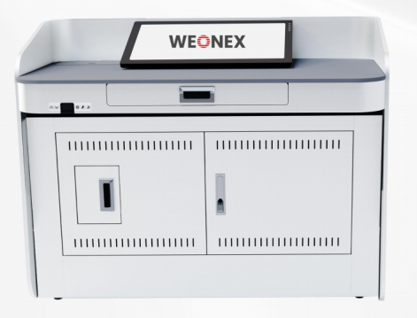

·anti-static ·moisture-proof design
·adjustable height ·HD touchscreen

Capactitive Touchscreen
23.8-inch Full HD capacitive touchscreen with 10-point multi-touch, designed for responsive, lag-free classroom operation.

Height-Adjustable Design
Adjustable height accommodates users of all heights, and the compact design saves classroom space. Optional casters enable easy repositioning.

Pull-out Keyboard Tray
Retractable keyboard and mouse bracket provides a clean workspace while remaining fully functional when extended.

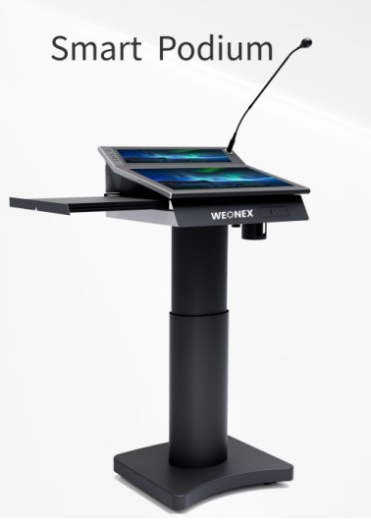
·height adjustable ·hidden side tray
·sleek all-in-one form ·dual-screen interaction
·capacitive touchscreen ·gesture control

Sleek All-in-one Form
Sleek, matte-finished form that fits any modern classroom and meeting room. Integrated functionality removes clutter for a clean, professional workspace.

Dual-Screen Interaction
Features split-screen, screen mirroring and extended display. One-click quick switching enables flexible dual-screen operation for efficient teaching.

Height Adjustable
Whisper-quiet electric lift for seamless height adjustment, ideal for both seated and standing teaching.
Smart Mobile Screen
·freely customize the app ·easy to move
·adjustable height & angle ·19 countries translation
·battery powered ·27”/32” at your choice
·Android 13 ·Wi-Fi 2.4GHz & 5GHz

Move Any Room, Anytime
Moving effortlessly anywhere, supporting touch operation and multi-functional scenarios.

Customizable Viewing Experience
Effortlessly adjust the screen’s angle, orientation and height for optimal comfort and usability.

Multilingual Speech-to-Text
19 languages supported, instant on-screen transcription.

Access to Millions of Apps
Install your favorite apps for fully customizable use cases.

Mobile Stand
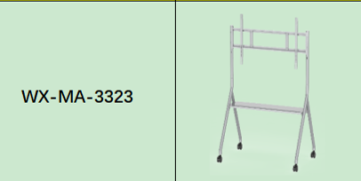
·Fixed shelf provides a convenient place to set laptops, notebooks, pens, etc.
·Simple design and hassle-free installation.
·Universal casters for effortless mobility and flexible placement.
·A-Frame design provides sturdy, anti-tip support for large-format displays.

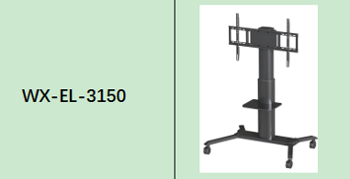
·Smooth electric height adjustment for optimal viewing positions in any setting.
·Sturdy wide base prevents tipping and keeps the display stable during movement and use.
·Convenient storage shelf for laptops and presentation accessories.
·Heavy-duty lockable casters for smooth mobility on all floor types.

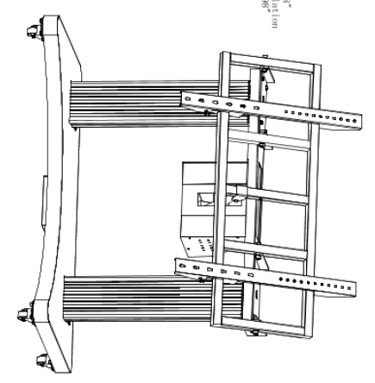6084F
·Four robust lockable casters allow smooth mobility across floors and secure placement during use.
·Wide, low-profile base ensures reliable stability, even during height and tilt adjustments.
·Combined motorized lift and tilt offer hands-free adjustment for versatile classroom and meeting setups.
·Adjustable VESA bracket fits most large-format displays for quick and secure installation.

OPS
·Android OPS, EDLA OPS
·plug-and-play integration
·high-performance computing
·versatile connectivity

Conference Kits
·3 in 1 combine with array mic, speaker and share
·8-array mic with AI sound optimization
·integrated cable management

Stylus
·Multi-function buttons support one-tap and long-press commands for quick presentation control.
·Ultra-fine tip delivers precise, lag-free writing and drawing with natural hand feel.
·High-sensitivity touch recognition for delicate detail creation and clear handwriting.
·Combines a stylus, remote, and pointer in one compact pen for easy handling and storage during class or conference use.

Pluggable Camera
·pluggable 48MP AI+8 array mic
·auto framing 4K+array mic

Digital Class Signage电子班牌
·class schedule display
·attendance & ID verification
·school announcement & alerts
·interactive learning features
Software Kits
WNEX Share投屏
·easy wireless connection and interactivity
·screen mirroring and data sharing
·multi-device display solution

WNEX Meeting 远程互动
·dual modes: Remote Teaching & Online Conferencing
·seamless cross-device data synchronization & multi-party access
·interactive tools for Engaging & Effective interaction
WNEX Group 小组讨论
·Real-time classroom engagement with homework assignment, content sharing, and instant Q&A tools.
·Streamline remote meetings with instant meeting access, real-time screen/file sharing, and integrated video calls.
·Transform any captured content into interactive questions in seconds.

WNEX TabletLinks Pad教学
·Instantly manage all student tablets centrally with screen lock, maintaining a distraction-free classroom.
·One-click content distribution to instantly send courseware, exercises, and materials to all student devices.
·Boost classroom interaction with fast quiz creation from courseware, enabling live assessment and timely responses.
·Instant student work upload, presentation, and group comparison tools for interactive classroom feedback.

WNEX DMS
·Access real-time device status on a centralized dashboard with intuitive visual charts. Monitor usage trends and idle device data to streamline on-site operation, maintenance and resource planning.
· Filter, edit and delete records with ease, and export all key data in one click. Simplify daily data sorting, archiving and analysis for effortless admin management.
·Remotely manage displays and recording devices individually or in batches. Custom alerts and scheduled power functions enable full lifecycle control and reduce on-site maintenance.

